

**Weather Forecasting System**

**Submitted by**

**Hitesh Kumar S (231801059)**

**CS23333-Object oriented Programming using java**

**Department of Artificial Intelligence and Data Science**

**Rajalakshmi Engineering College, Thandalam**

**Nov 2024**

# ABSTRACT

Weather prediction is the application of science and technology to predict the state of the atmosphere for a given location. Here this system will predict weather based on parameters such as temperature, humidity and wind. This system is a web application with effective graphical user interface. To predict the future’s weather condition, the variation in the conditions in past years must be utilized. The probability that it will match within the span of adjacent fortnight of previous year is very high .We have proposed the use of linear regression for weather prediction system with parameters such as temperature, humidity and wind. It will predict weather based on previous record therefore this prediction will prove reliable. This system can be used in Air Traffic, Marine, Agriculture, Forestry, Military, and Navy etc.

# LIST OF FIGURES

|  |  |  |
| --- | --- | --- |
| **Fig. No.** | **Figure Description** | **Page No.** |
| Figure 1.1 | System Diagram | 2 |
| Figure 1.2 | JSON Object Diagram | 4 |
| Figure 2.2 | UI Design | 12 |

**TABLE OF CONTENTS**

Certificate i

Declaration of student ii

Preface Error! Bookmark not defined.

Acknowledgement iv

Abstract v

List of Figures… vi

1. Introduction. 1
   1. Introduction to Weather forecasting 1
   2. Methodology used 2
   3. Technologies used… 3
      1. Machine Learning – Linear Regression 3
      2. Javascript 3
      3. Json… 4
      4. React.JS 4
      5. Adobe Illustrator 5
      6. Python 5
      7. Weather API 6
2. Software Requirement Specification. 7
   1. Problem Statement 7
   2. Project Scope 7
   3. Design and Implementation Constraint 7
   4. User Documentation… 8
   5. Assumptions and Dependencies 8
   6. System Features 8
      1. Actors 7
   7. Functional Requirements 8
      1. Accessing database 8
      2. Predicting Algorithm................................... 8
      3. Actions performed by system 9
   8. Non Functional Requirements 9
      1. User Non Functional Requirements 9
      2. System Non Functional Requirements 9
      3. Other Non-Functional Requirements 9
   9. Other Requirements 9
      1. Performance Requirements… 9
      2. Safety Requirements 9
      3. Security Requirements… 10
      4. Hardware Requirements… 10
      5. Software Requirements… 10
3. Design 11
   1. Introduction 11
      1. Proposed approach 11
      2. Weather Prediction System Architecture 12
   2. UI Design 13
4. Testing 14
   1. Unit Testing 14
   2. Integration Testing 14
5. Results 15
6. Deployment 17
   1. Purpose 17
   2. Preparation and Procedure 17
   3. Product Deployment 17
   4. Environment Variables 17
7. Conclusion 18
8. Future Scope 20
9. Reference 21
10. Appendix… 22

## Chapter 1 Introduction

#### Introduction to Weather Forecasting

Weather forecasting is the task of predicting the state of the atmosphere at a future time and a specified location. Traditionally, this has been done through physical simulations in which the atmosphere is modeled as a fluid. The present state of the atmosphere is sampled, and the future state is computed by numerically solving the equations of fluid dynamics and thermodynamics. However, the system of ordinary differential equations that govern this physical model is unstable under perturbations, and uncertainties in the initial measurements of the atmospheric conditions and an incomplete understanding of complex atmospheric processes restrict the extent of accurate weather forecasting to a 10 day period, beyond which weather forecasts are significantly unreliable. Machine learning, on the contrary, is relatively robust to perturbations and doesn’t require a complete understanding of the physical processes that govern the atmosphere. Therefore, machine learning may represent a viable alternative to physical models in weather forecasting.

Machine learning is the ability of computer to learn without being explicitly programmed. It allows machines to find hidden patterns and insights. In supervised learning, we build a model based on labeled training data. The model is then used for mapping new examples. So, based on the observed weather patterns from the past, a model can be built and used to predict the weather.

This project work focuses on solving the weather prediction anomalies and in-efficiency based on linear regression algorithms and to formulate an efficient weather prediction model based on the linear regression algorithms

#### Methodology used

In a developing country and an economy like India where major population is dependent on agriculture, weather conditions play an important and vital role in economic growth of the overall nation. So, weather prediction should be more precise and accurate. Weather parameters are collected from the open source . The data used in this project is of the years 2013-2019. The programming language used is ‘Python’. Fig. 1.1 visualizes the system in the form of a block diagram.

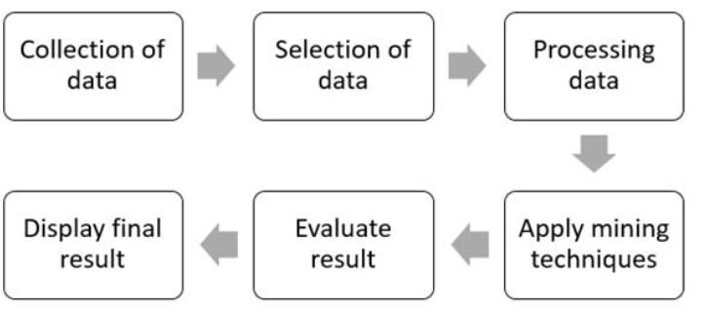

**Fig 1.1 System Block Diagram**

The weather is predicted using various indices like temperature, humidity and dew-point. Temperature is the measure of hotness or coldness, generally measured using thermometer. Units of temperature most frequently used are Celsius and Fahrenheit. We have used maximum and minimum temperature values along with normal temperature as different index values for prediction of the weather.

Humidity is the quantity of water vapor present in the atmosphere. It is a relative quantity.

Dew point is the temperature of the atmosphere (which varies according to pressure and humidity) below which water droplets begin to condense and dew is formed.

#### Technologies Used

##### Machine learning – Linear Regression

Linear regression is the most basic and frequently used predictive model for analysis. Regression estimates are generally used to describe the data and elucidate relationship between one or more independent and dependent variables. Linear regression finds the best-fit through the points, graphically. The best-fit line through the points is known as the regression line.

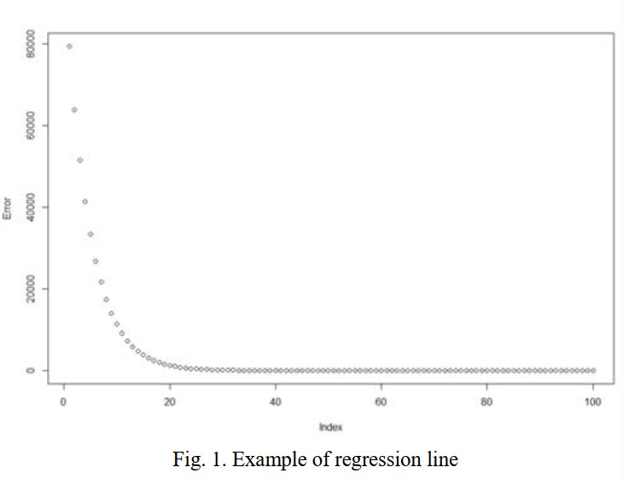

Fig. 1 is an example of the best-fit line. Here, the line can be straight or curved depending on the data. The best-fit line can also be a quadratic or polynomial which gives us better answer to our questions.

##### Javascript

JavaScript is a lightweight, interpreted programming language. It is designed for creating network-centric applications. It is complimentary to and integrated with Java. JavaScript is very

easy to implement because it is integrated with HTML. It is open and cross-platform. Once you learnt Javascript, it helps you developing great front-end as well as back-end softwares using different Javascript based frameworks like jQuery, Node.JS etc.

JavaScript is used to create interactive websites. It is mainly used for:

* + - * Client-side validation
      * Displaying pop-up windows and dialog boxes

##### Json

JSON (JavaScript Object Notation) is a lightweight format that is used for data interchanging. It is based on a subset of JavaScript language. It has been the preferred format because it is much more lightweight

JSON is built on two structures:

* A collection of name/value pairs. In various languages, this is realized as an object, record, structure, dictionary, hash table, keyed list, or associative array.
* An ordered list of values. In most languages, this is realized as an array, vector, list, or sequence.

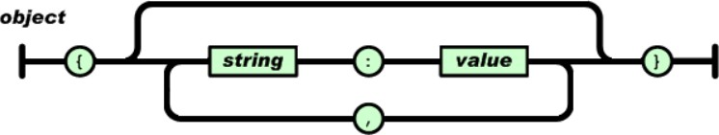

##### ReactJS

ReactJS is a declarative, efficient, and flexible JavaScript library for building reusable UI components. It is an open-source, component-based front-end library which is responsible only

for the view layer of the application. It was initially developed and maintained by Facebook and later used in its products like WhatsApp & Instagram.

The main objective of ReactJS is to develop User Interfaces (UI) that improves the speed of the apps. It uses virtual DOM (JavaScript object), which improves the performance of the app. The JavaScript virtual DOM is faster than the regular DOM. We can use ReactJS on the client and server-side as well as with other frameworks. It uses component and data patterns that improve readability and helps to maintain larger apps.

##### Adobe After Effects

Adobe After Effects is a digital visual effect, motion graphics, and compositing application developed by Adobe Systems and used in the post-production process of film making and television production. Among other things, After Effects can be used for keying, tracking, compositing, and animation. It also functions as a very basic non-linear editor, audio editor, and media transcoder.

After Effects has extensive plug-in support; a broad range of third-party plug-ins are available. A variety of plug-in styles exist, such as particle systems for realistic effects for rain, snow, fire, etc.

With or without third-party plug-ins, After Effects can render 3D effects. Some of these 3D plug- ins use basic 2D layers from After Effects. In addition to 3D effects, there are plug-ins for making video look like film or cartoons; simulating fire, smoke, or water; particle systems; slow motion; creating animated charts, graphs, and other data visualization; calculating the 3D movement of a camera in a 2D video shot; eliminating flicker, noise, or rigging lines; translating timelines from FCP or Avid; adding high-end color correction; and other workflow improvements and visual effects.

##### Python

Python is an interpreted, object-oriented, high-level programming language with dynamic semantics. Its high-level built in data structures, combined with dynamic typing and dynamic

binding, make it very attractive for Rapid Application Development, as well as for use as a scripting or glue language to connect existing components together. Python's simple, easy to learn syntax emphasizes readability and therefore reduces the cost of program maintenance. Python supports modules and packages, which encourages program modularity and code reuse. The Python interpreter and the extensive standard library are available in source or binary form without charge for all major platforms, and can be freely distributed

##### Weather API

Weather APIs are Application Programming Interfaces that allow you to connect to large databases of weather forecast and historical information. The weather API provides enough weather data for basic weather information (eg current weather, forecast, UV index data, and historical weather information). You can use geolocation and names to get a city location.

## Chapter 2 Problem Identification

#### Problem Statement

Weather prediction is a useful tool for informing populations of expected weather conditions. Weather prediction is a complex topic and poses significant variation in practice. We will attempt to understand and implement a weather prediction application using the linear regression.

#### Project Scope

* Weather forecasts are made by collecting as much data as possible about the current state of the atmosphere (particularly the temperature, humidity and wind) to determine how the atmosphere evolves in the future.
* However, the chaotic nature of the atmosphere makes the forecasts less accurate as the range of the forecast increases.
* Traditional observations made at the surface of atmospheric pressure, temperature, wind speed, wind direction, humidity, precipitation are collected routinely from trained observers, automatic weather stations or buoys.During the data assimilation process, information gained from the observations is used In conjunction with a numerical model's most recent forecast for the time that observations were made to produce the meteorological analysis. The complicated equations which govern how the state of a fluid changes with time require supercomputers to solve them.
* The output from this model can be used the weather forecast as alternative.

#### Design and Implementation Constraints

The product is developed using API server. The back-end database are CSV files on the basis of that, the prediction takes place. The product is a general-purpose application software in which any user can gather the predicted information. The linear regression is used that predicts the weather based on the previous analysis of a data.

Major Components:

* Data Collection: The feeding historical data to the system, this could be from specific region.
* Data Cleaning: Under this component the data like the missing data, duplicated data is found and bad data is weed out
* Data selection: Under this stage, relevant data related to analysis is retrieved and classified under 6 attributes.

#### User Documentation

The product is a general-purpose application software where any user can access the software to gather information about the weather based on a current or a previous data analysis. In this product the software makes a request to the server to access the current dataset through which the data is analyzed using various machine learning algorithms.

#### Assumptions and Dependencies

* The software product is dependent on a dataset that is been retrieved from the server using various commands.
* The product will work based on the algorithm that has been discussed above.

#### System Features

##### Actors

* + - * User
      * Historical data provider
      * Administrator

#### Functional Requirements

##### Accessing a database

* + - * The system should allow administrator to add historical weather data.
      * The system should be able to recognize patterns in temperature, humidity, and wind with use of historical data.

##### Prediction algorithm

* + - * System should periodically apply prediction algorithms or models on obtained data and store results to central database.
      * System shall obtain and display confidence value for each prediction given to user.

##### Actions performed by system

* + - * System shall allow users to check weather for future three days.

#### Non-Functional Requirements

##### User Non-Functional Requirements

* + - * System shall allow for users to get prediction for weather within almost two mouse clicks.
      * System should ensure that features that do not require a user to be logged in.

##### System Non-Functional Requirements

* + - * System should be able to run with core functionality from computer system.
      * System should be able to show interactive animations to users regarding current and future climatic conditions.

##### Other Non-Functional Requirements

* + - * System should textual prediction of climate conditions.

#### Other Requirements

##### Performance Requirements

The proposed software that we are going to develop will be used as the general-purpose application software. Therefore, it is expected that the database would perform functionally all the requirements that are specified by the user.

##### Safety Requirements

The database may get crashed at any certain time due to virus or operating system failure. Therefore, it is required to take the database backup

##### Security Requirements

We are going to develop a secured database for the user. Software Quality Attributes. The Quality of the database is maintained in such a way so that it can be very user friendly to all the users.

##### Hardware Requirements

The system requires a database in order to store persistent data.

##### Software Constraints

The development of the system will be constrained by the availability of required software such as web servers, dataset and development tools.

## Chapter 3

**Design**

Among modeling languages Unified Modeling Language (UML) has become most popular. UML is commonly used in the design and implementation of any system and software architectures. To achieve functional and non functional requirements of the system, UML model helps. In order to initiate the programming phase of building software, UML tools help in the creation of source code from UML diagram. The main objective of this paper to model a Weather Prediction System (Linear Regression approach) using UML. Weather prediction is a challenging area. The future weather conditions are predicted by trained regression model. In this chapter, we proposed a UML model for Weather Prediction using linear regression which provide a technique for predicting weather. This proposed enhanced method for weather prediction has advantages over other techniques

#### Introduction

In software industries, Object Oriented Development process is widely used. Object-Oriented Programming has heavily contributed toward a standardized method of modeling known as the Unified Modeling Language (UML). UML has become synonym for software modeling. UML is commonly used to model the software architecture as per the requirements and it includes a set of graphic notation techniques to create visual models of software-intensive systems. With the help of different UML diagrams for building the software, source code can be easily generated. The correctness of source code depends on the UML specification which needs to be standard, complete, precise, and unambiguous. A good UML specification leads to clearly defined semantics and an efficient code can be generated. The project is based upon the predicting Weather's condition.

##### Proposed approach

The proposed System using an enhanced approach is tested using the dataset of last 6 years from (2013-2019). The results are compared with previous methods results. The proposed enhanced method for weather prediction has advantages over the traditional techniques. This model produces the most accurate forecasts in comparison with previous techniques. This system can help the meteorologist to predict the future weather easily with accuracy.

##### Weather Prediction System Architecture

The system is developed in python along with javascript. Daily data sets of last 6 years (2013- 2019) has been fetched to train our model. The system takes input from the datasets and produces the result.

The system building process consists of following sequential steps:

1. Fetching the dataset
2. Cleaning the dataset
3. Selection of the features of dataset
4. Train Model
5. Use the model to predict results.

#### Use-Case Diagram

An interaction between a user and a system is described by use case diagram. Use case diagrams describe what a system does from the standpoint of an external observer. The emphasis is on what a system does rather than how. Use case diagrams are closely connected to scenarios. A scenario is an example of what happens when someone interacts with the system. A use case diagram is a collection of actors, use cases, and their communications.

For initial development we can use this use case. In this use case diagram we can see following use cases and actor. Use cases are self explanatory and they represent the main functions of Weather Prediction System.

#### Ui Design

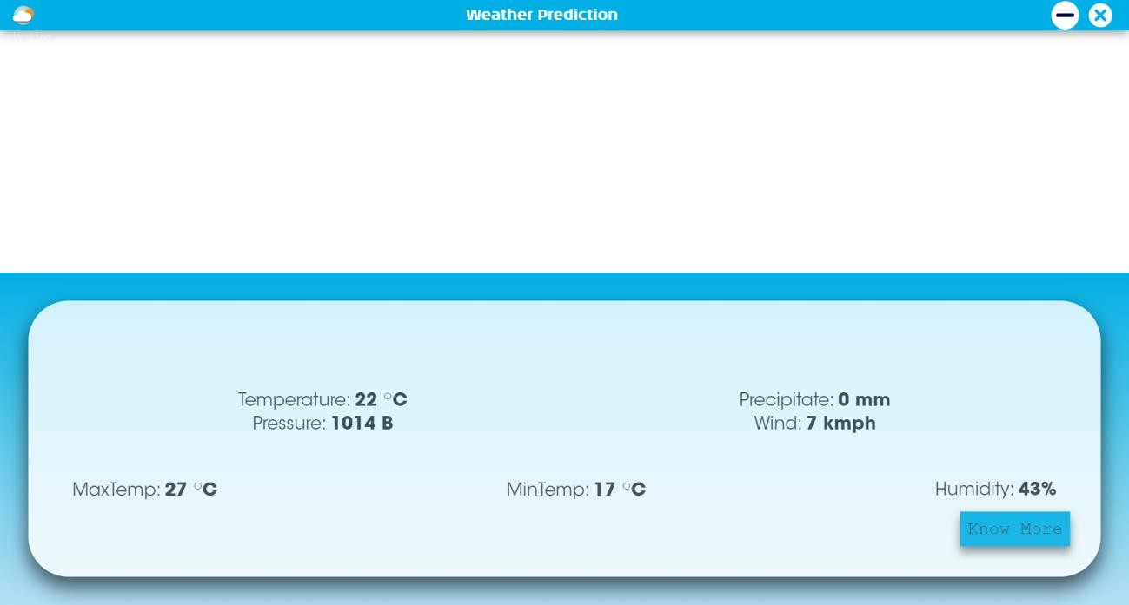

## Chapter 4 Testing

Testing is the process of evaluating a system or its component with the intent to find whether it satisfies the specified requirement or not. Testing is executing a system in order to identify any gaps, errors, or missing requirements in contrary to the actual requirements. Systems should not be tested as a single, monolithic unit. The testing process should therefore proceed in the stages where testing is carried out incrementally in conjunction with system implementation. Errors in program components may come to light at a later stage of the testing process. The process is therefore an iterative one with information being fed back from later stage to earlier parts of the process. Following testings were done during the course of our project.

#### Unit Testing

Unit testing focuses verification efforts on the smaller unit of software design. Using the detailed design description as a guide, important control paths are tested to uncover errors within the boundary of the module. The relative complexity of the test and the error detected as a result is limited by the constraint scope established for unit testing. The unit test is always white box oriented, and the step can be conducted in parallel for multiple modules

* + - Tested individual python file by debugging and using print statement
    - Individual Component rendering

#### Integration Testing

With unit testing the modules may function properly, but at times they may have inadvertent affect on another, sub function when combined, may not produce the desired functions; individually acceptable impression may be signed to unacceptable levels then global data structure may present problems. Integration testing is a systematic technique for constructing the program structure while at the same time conducting tests to uncover errors associated with interfacing. The objective is to take unit tested modules and build a program structure that has been dictated by the design.

## Chapter 5 Results

1. **Splash Screen**

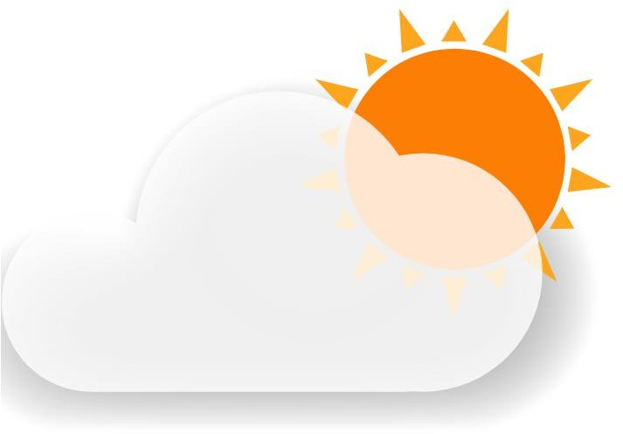

1. **Main Page**



## Chapter 6 Deployment

#### Purpose of Deployment Phase

The deployment phase is the final phase of the software development life cycle (SDLC) and puts the product into production. After the project team tests the product and the product passes each testing phase, the product is ready to go live. This means that the product is ready to be used in a real environment by all end users of the product.

There are various phases of the deployment process the project team must follow to ensure the code and technology deploy appropriately. The phases include deployment preparation and procedures, product deployment, transferring ownership of the product, and closing the deployment phase.

#### Preparation and Procedures

In the preparation and procedures phase, the project team installs the software and conducts another test to ensure successful installation. Once the installation is complete, the project team creates operating procedures, which include instructions for how the software should work in the information technology environment. If there are issues with system functionality, the operating instructions also provide a mitigation plan to help the end user repair the issue.

#### Product Deployment

Under the product deployment phase, the project team implements the programming and coding to each system location. For example, say a company has two regional worksites in Noida and Kolkata and over 2,000 computer systems. The deployment phase includes pushing the program and coding to each regional site and each computer system.

#### Environment Variables:

* + - **Visual Studio Code** - Visual Studio Code is an [IDE](https://en.wikipedia.org/wiki/Integrated_development_environment) developed by Microsoft for [Windows](https://en.wikipedia.org/wiki/Windows), [Linux](https://en.wikipedia.org/wiki/Linux) and [macOS](https://en.wikipedia.org/wiki/MacOS) It includes support for [debugging](https://en.wikipedia.org/wiki/Debugging), embedded [Git](https://en.wikipedia.org/wiki/Git) control and [GitHub](https://en.wikipedia.org/wiki/GitHub), [syntax highlighting,](https://en.wikipedia.org/wiki/Syntax_highlighting) [intelligent completion](https://en.wikipedia.org/wiki/Intelligent_code_completion), [snippets](https://en.wikipedia.org/wiki/Snippet_(programming)), and [code refactoring](https://en.wikipedia.org/wiki/Code_refactoring).

It is highly customizable, allowing users to change the [theme](https://en.wikipedia.org/wiki/Theme_(computing)), [keyboard shortcuts](https://en.wikipedia.org/wiki/Keyboard_shortcut), preferences, and install [extensions](https://en.wikipedia.org/wiki/Plug-in_(computing)) that add additional functionality. The source code is [free and open source](https://en.wikipedia.org/wiki/Free_and_open_source) and released under the permissive [MIT License.](https://en.wikipedia.org/wiki/MIT_License) The compiled binaries are [freeware](https://en.wikipedia.org/wiki/Freeware) and free for private or commercial use.

Working with Git and other SCM providers has never been easier. Review diffs, stage files, and make commits right from the editor. Push and pull from any hosted SCM service. If want to add new languages, themes, debuggers, and to connect to additional services just install the extensions. Extensions run in separate processes, ensuring they won’t slow down the editor.

* + - **Adobe Illustrator**- Adobe Illustrator is a software application for creating drawings, illustrations, and artwork using a Windows or MacOS computer. Illustrator was initially released in 1987 and it continues to be updated at regular intervals, and is now included as part of the Adobe Creative Cloud. Illustrator is widely used by graphic designers, web designers, visual artists, and professional illustrators throughout the world to create high quality artwork. Illustrator includes many sophisticated drawing tools that can reduce the time need to create illustrations

One of Adobe Illustrator’s most important features is that the quality of artwork created using Illustrator is independent of the resolution at which it is displayed. This means that an image created in Illustrator can be enlarged or reduced without sacrificing image quality. This is an attribute of vector artwork, which uses mathematical relationships in describing lines, arcs, and other parts of an illustrator. By comparison, photographs edited using tools such as Adobe Photoshop are resolution-dependent, and image quality decreases when an image is enlarged

# CONCLUSION

This research suggests and proposes an efficient and accurate weather prediction and forecasting model using linear regression concept. This concept is a part of machine learning. It is a very efficient weather prediction model and using the entities temperature, humidity and pressure, it can be used to make reliable weather predictions. This model also facilitates decision making in day to day life. It can yield even better results when applied to cleaner and larger datasets. Pre- processing of the datasets is effective in the prediction as unprocessed data can also affect the efficiency of the model.

# FUTURE SCOPE

#### Scope of Weather Prediction

* + - Our system will only provide weather prediction of Amabla only.
    - Prediction will be done based on historical weather activities like based on past temperature, wind, etc. pattern what will be the future weather.

#### Future Enhancement

* + - Mobile and IOS application Integration.
    - Addition of new cities weather dataset to predict there future weather also.
    - Addition of new Indices.
    - Animation like snow and functions like notifications can also be added.

# REFERENCES

1. [https.wikipedia.com](http://www.wikipedia.com/)
2. [https.w3schools.com](http://www.w3schools.com/)
3. [https.reactjs.org](http://www.reactjs.org/)
4. [https://dev.to/achowba/building-a-modal-in-react-](https://dev.to/achowba/building-a-modal-in-react-15hg#%3A~%3AtargetText%3DOpen%20the%20Modal.js%20file%2C%7B%7B%20transform%3A%20props.show%20%3F) [15hg#:~:targetText=Open%20the%20Modal.js%20file,%7B%7B%20transform%3A%20props.sho](https://dev.to/achowba/building-a-modal-in-react-15hg#%3A~%3AtargetText%3DOpen%20the%20Modal.js%20file%2C%7B%7B%20transform%3A%20props.show%20%3F) [w%20%3F](https://dev.to/achowba/building-a-modal-in-react-15hg#%3A~%3AtargetText%3DOpen%20the%20Modal.js%20file%2C%7B%7B%20transform%3A%20props.show%20%3F)